Year 9 Science: Research Assignment

CERN: developing our understanding of the atom

Name: ___________________________________________________
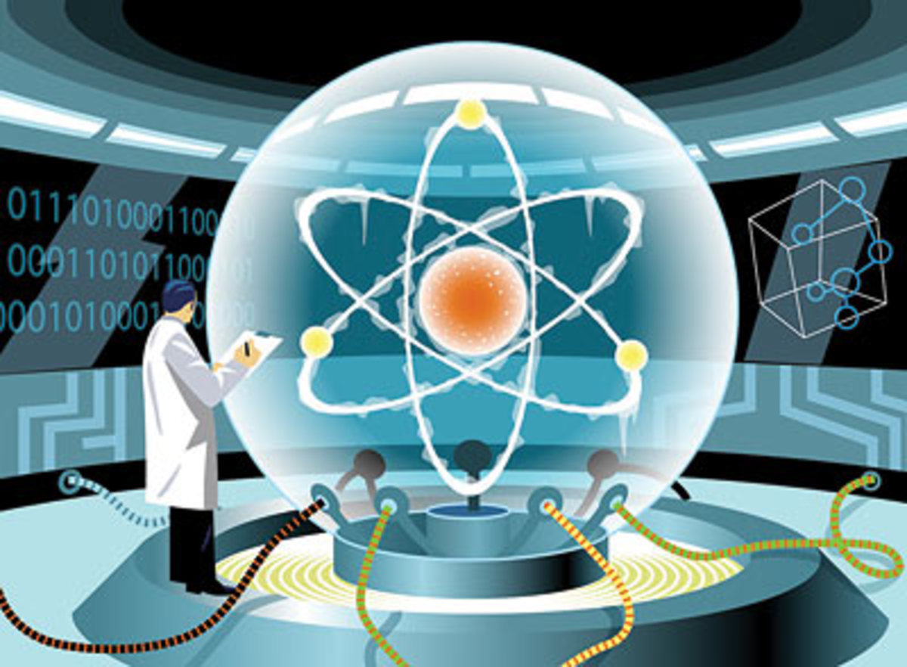
The European Organisation for Nuclear Research is known as CERN and is based on the border of France and Switzerland. It has been responsible for developing scientists’ understanding of atoms for over sixty years.

Your task is to produce an informative brochure designed for the general public, detailing the work conducted at CERN and how it is helping to improve scientists’ understanding of atoms.

You must include the following details in your brochure:

- A description of CERN, what it stands for and where it is located
- When CERN was founded, why and by whom
- What equipment and instrumentation scientists can use at CERN
- At least 2 detailed examples of discoveries made about atoms at CERN
- 1 detailed example of an experiment currently being conducted about atoms at CERN today

Your brochure should be neat, legible and eye-catching with sensible use of colour and labelled diagrams to help make it appropriate for the general public.

You will have 2 sessions of in-class time to research and commence the brochure. Present your brochure on a single piece of ‘A4’ paper folded into three equal parts.

Remember you are not allowed to copy your research notes directly from the Internet or book as this is Plagiarism (stealing someone else’s work). To help prevent this you may want to write your notes in dot points in the structured overview sheet provided.

The brochure will be due 2 days after the final class.

Due date: ___________________________________

Your brochure must be submitted in person to your teacher on or before the due date.
Developing our understanding of the atom –
Marking Key/Rubric

Name: ______________________________________________

Assessments |  | Your Mark | Total Mark Available
Descriptive information | What and where CERN is |  | 2
Origin | When and why CERN was founded, and by whom |  | 3
Available technology | Equipment and instrumentation used |  | 2
Summary of discoveries | 2 detailed discoveries made about atoms |  | 4
Current work | 1 detailed explanation of a current experiment about atoms |  | 2
Diagram | Include diagrams where appropriate |  | 1
Presentation  *Attractive brochure style with eye-catching elements  *Information in clear, legible and logical format  *Use of heading and Images/ diagrams to support information |  |  | 3
Total Mark |  |  | 17

Comment: ________________________________________________________________________________
_____________________________________________________________________________________________

